Data Archive Solution

Data Hub: Data Archive Solution
<Project Number>

Origin/Author :

Approved by :

Date Approved:

Overview
Data Hub is an Azure-based data integration solution that consolidates data from APO data from SFTP, MDM, and Hive source systems and sends it to Noodle for demand forecast generation. To ensure proper management and organization of the data within the Data Hub and share the error information with business, we are implementing following Archive solution to minimize cost and simplifying compliance.
This document outlines the design and implementation details of the Data Archive Solution for Noodle Data Hub Solution. The solution aims to address data retention and compliance requirements by automating the Archive process.

Data Storage
Source Data is ingested into a Data Hub for processing. The Data Hub has various storage zones used to process the data before it sending to Noodle. Based on solution design, the data remains in the designated zones indefinitely, which can potentially have implications on both platform performance and operational costs as time progresses.

Below is a diagram providing a detailed view of the Zone storage and its usage. Landing zone and Provisional Areas keep data in the file format sent by the source and or received from the target system. Silver and Gold Zones store data in delta table format, whereas bronze zone is a transient state of data.

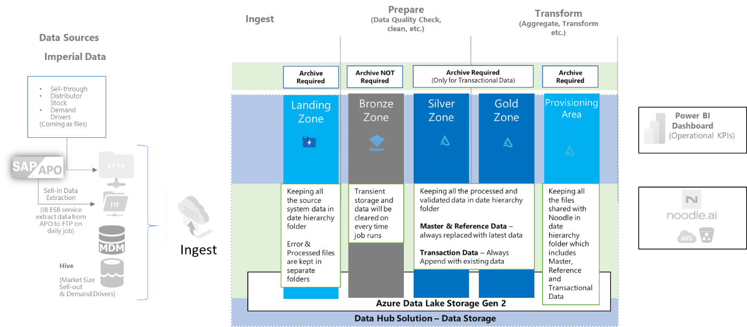
Figure 1 – Data Storage in Data Hub
- Landing Zone – Archive Required: Keeping all the source system data in date hierarchy folder. Error & Processed files are kept in separate folders
- Bronze Zone - Archive NOT Required: Transient storage and data will be cleared on every time job runs
- Silver Zone – Archive Required for Transactional Data only: Keeping all the processed and validated data in date hierarchy folder. Master & Reference Data – always replaced with latest data. Transaction Data – Always Append with existing data
- Gold Zone – Archive Required: Archive Required for Transactional Data only: Keeping all the processed and validated data in date hierarchy folder. Master & Reference Data – always replaced with latest data. Transaction Data – Always Append with existing data
- Provisioning Area – Archive Required: Keeping all the files shared with Noodle in date hierarchy folder which includes Master, Reference and Transactional Data

Data Archive Solution
The Data Archive Solution leverages native features from Azure and Databricks to provide a flexible and cost-effective data Archive framework. The solution helps the business address the challenge that some of its data needs to be accessed frequently to support core operations and processes, while other datasets become less frequently accessed over time.

The solution provides low cost and long-term storage for less frequently accessed data. For the frequently accessed active data, the solution keeps that data in high performance main storage of the Data Hub solution to ensure low latency access for business.

Archive Approach
Data Hub has different storage zones to process the files as per business needs before sending to Noodle for demand forecast. Two different archive approaches are required to cover the various Data Hub zones; Data Lifecycle Policy for Landing zone and Provisioning Area, and Maintenance Routine for Silver and Gold zones. As above, Bronze zone does not require archiving.

Data Lifecycle Policy
Blob storage lifecycle management feature from Azure storage account provides the ability to set up rules that automatically move files (data / blobs) between the Hot and Archive storage tiers.
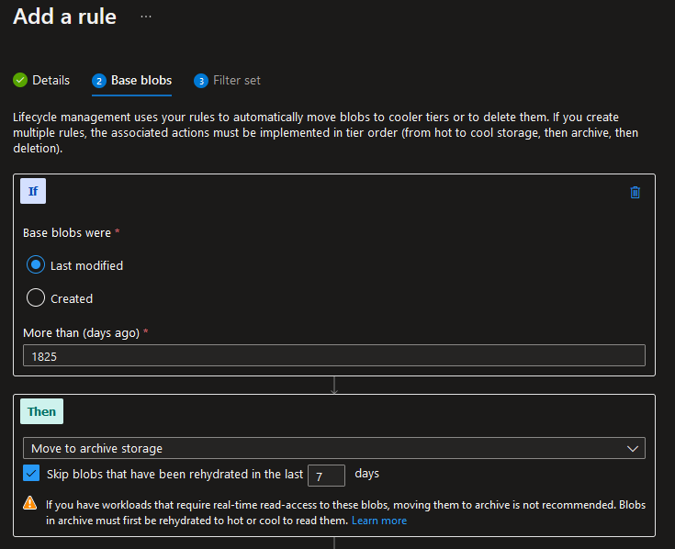
Figure 2 – Data Lifecycle Policy Rule
Using this policy, we can setup an Archive Policy to move Hot to Archive tier after 5 years (1825 days). This can be used in zones where data is stored as file format such as csv, txt and etc.

Maintenance Routine
For data stored in Delta Lake tables, lifecycle policies may not effectively transition older data to archive storage. This is because delta format files reference each other for integrity and are managed through Databricks delta tables.
As lifecycle policies apply to each individual file, and archive each file individually, it would impact the file references and integrity in delta tables.
Therefore, we should leverage Spark SQL to manually copy older data from the delta tables into our archive storage. Once the data has been successfully copied, we can then delete the older data from the delta tables.
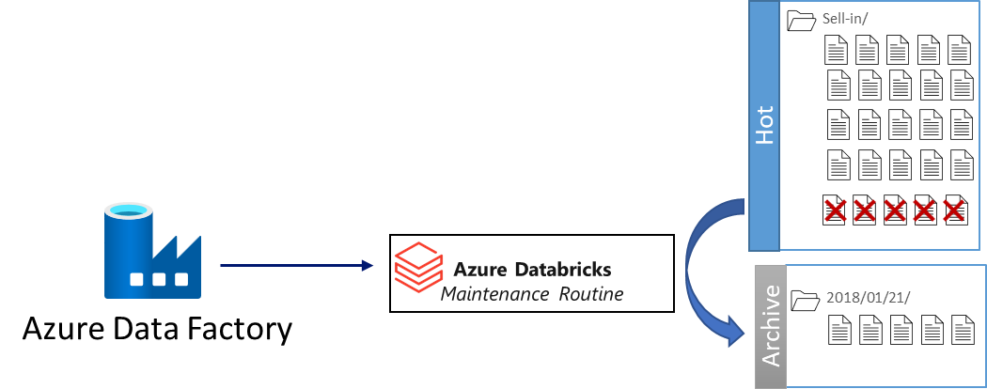
Figure 3 – Maintenance Routine

Implementation Plan
Data Hub processes the data as per business rules and to perform this operation, it follows standard patterns. As per the pattern, data flows through different zones before we share the data with Noodle.
Each zone has its own purpose and can handle files is one of two formats (Parquet or flat text file), and the format of the file is retained within that zone.

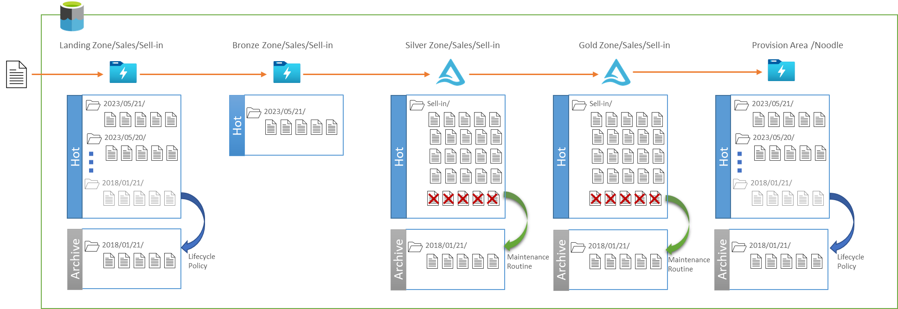
Figure 4 – Data Storage in Data Hub
Decision justification for each zone and the approach to archive data is defined in the below table.
Archive Solution | Considerations | Rationale | Scope
Lifecycle Policy | Lifecycle Policy is a feature that automates the management of data in Azure storage accounts (Data lake Gen 2). It provides a set of rules and actions to move files from hot tier to archive tier. | Lifecycle policy apply at each file level and is well suited for the file storage and independent blobs /files/objects without references. | - Landing Zone  - Provisioning Area
Maintenance Routine | Routine task will perform the data movement from Hot tier to Archive tier on scheduled interval. Selection of data is parameterized and based on the filter criteria passed, routine will move the data to appropriate tier.  Master data jobs always delete then load full copy, and hence not required to archive.  Transactional Data always appends, and accumulates over time. Hence it required to archive after predefine period mentioned in the data retention policy | Routine will be implemented in pyspark function to run on delta tables to archive the older data.  Delta file location and date filter are passed as parameter to this function to perform the action. | - Silver Zone  - Gold Zone

Define Data Lifecycle Policy
To implement Azure Data Storage Lifecycle Policy in the Data Hub solution, the process involves defining rules based on data usage patterns, specifically the "Last Modified Date" property.

It is recommended to set the rule's duration based on the desired data retention period, such as 1825 days (corresponding to 5 years * 365 = 1825 days), and specify the action to move the data to the Archive tier.

This ensures that data meeting the specified criteria will be automatically transitioned to a lower-cost storage tier for long-term retention.

Define Maintenance Routine Activity
To implement Maintenance Routine Activity in the Data Hub solution, the steps required will filter out the older data based on “Process Date” field.
Create a new storage container for archive and configure the storage container's lifecycle policy to automatically move files to the archive tier after a day. This ensures that any files moved as part of routine activities will be automatically transferred to the archive tier by default.
Perform a copy operation to transfer the data from the source location to the new archive container. It is recommended to maintain the folder hierarchy similar to the source system. The data should be stored in the parquet file format for optimized storage instead of delta format.
After successful data copy to archive location, next step will be performing delete older data based on above “Process Date” filter from the source location to free up the space in hot tier storage.

